**Guidelines for Data Visualization and Analysis Project**

**About the Project:**

In this project, you will be working with a dataset from the Superstore, aiming to answer 30 scenario-based questions through data visualisation and analysis. Your objective is to select the best chart for each question, explain your choice. This project will showcase your proficiency in data visualisation, critical thinking, and effective communication.

**Skills Required:**

* Proficiency in data visualisation concepts and techniques.
* Familiarity with Tableau or a similar data visualisation tool.
* Strong analytical and problem-solving skills.
* Ability to choose appropriate charts based on data characteristics and question requirements.
* Clear and concise communication skills.

**Deliverables:**

* A Google document containing solutions to the scenario based questions including the screenshot of relevant chart picked for each scenario, presented in a concise and well-structured format. Make sure to provide explanations that highlight your problem-solving skills.

**Rubrics for Assessment:**

Question Responses:

* Accuracy and completeness of answers for all 30 questions.
* Clear and concise explanations that address the question's context.

Chart Selection and Explanation:

* Thoughtful rationale for choosing specific chart types.
* Justification based on data characteristics, context, and communication goals.

Creative Enhancements:

* Effective use of creative elements to enhance visualisation quality.
* Enhancements that contribute to better understanding or engagement.

**Note**:

* Duplicate this document and proceed to write your solutions.
* For each scenario and question, provide a justification for the choice of chart type. Explain why it is the best option to visualise the data effectively.
* Attach screenshots of the charts you have created in Tableau for each scenario and question using the Superstore dataset. Label them clearly to match the corresponding questions in the Google Document.
* Submit the duplicated google doc file after completion.

Use these guidelines to structure your data visualisation and analysis project. Remember to maintain consistency in your responses, explanations, and visualisation styles. This project will not only demonstrate your skills but also your ability to effectively communicate complex information through visualisations. Good luck!

**Problem Statement: Choose the Best chart for any 30 scenario based questions from Superstore Dataset.**

Imagine you are a data enthusiast aiming to excel in data visualisation and analysis. In this task, you have been given any 30 scenario-based questions derived from the Superstore dataset, and your objective is to provide insightful answers using appropriate charts. For each question, you need to select a chart that best represents the data, explain why you chose that specific chart, and then proceed to build the chosen chart using Tableau.

Your responses should be succinct, organised, and illustrative of your problem-solving capabilities.

**Dataset Link:**

<https://community.tableau.com/s/question/0D54T00000CWeX8SAL/sample-superstore-sales-excelxls>

**Please keep in mind:**

1. **Answer Completion**: Ensure that you furnish answers for all any 30 questions and build charts for them.
2. **Encouraged Creativity**: Don't hesitate to employ visuals, creative elements, or any other innovative approaches to enhance the quality of your responses.

By completing this task effectively, you'll not only demonstrate your proficiency in data visualisation and analysis but also showcase your ability to effectively communicate complex concepts through both text and charts.

**Good luck!**

**Questions:**

1. Which product categories have the highest total sales in the "Superstore" dataset?

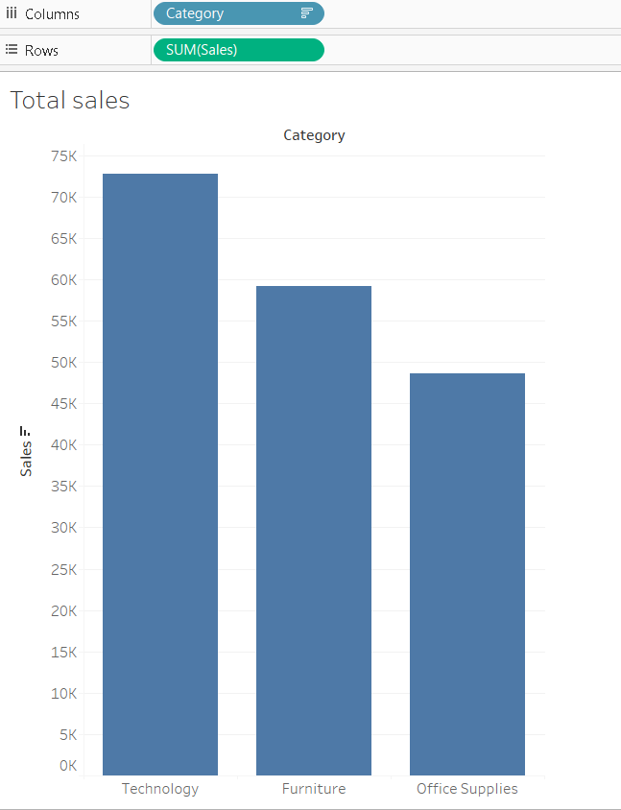

**Justification**: Ideal for comparing values across discrete categories. Horizontal layout supports long category names.

1. How is the total sales amount distributed among different product categories?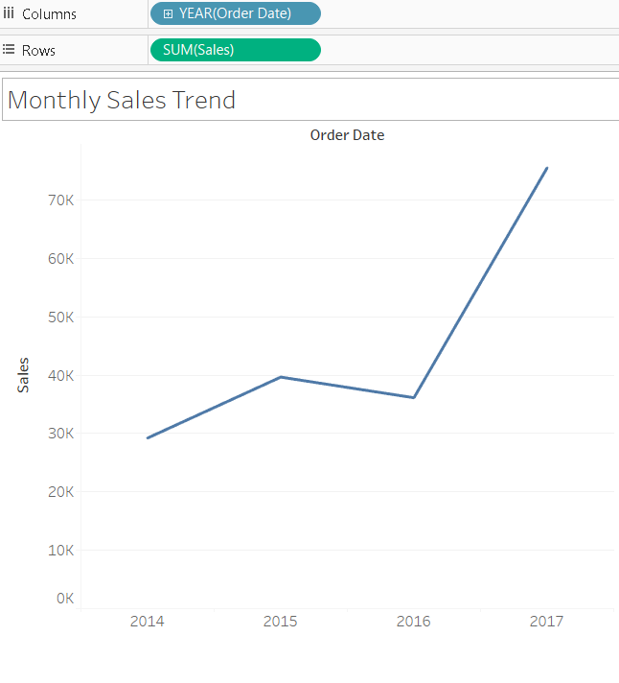

**Justification**: Shows trends and seasonality over time.

1. Can we analyze the sales performance of individual customers over time?

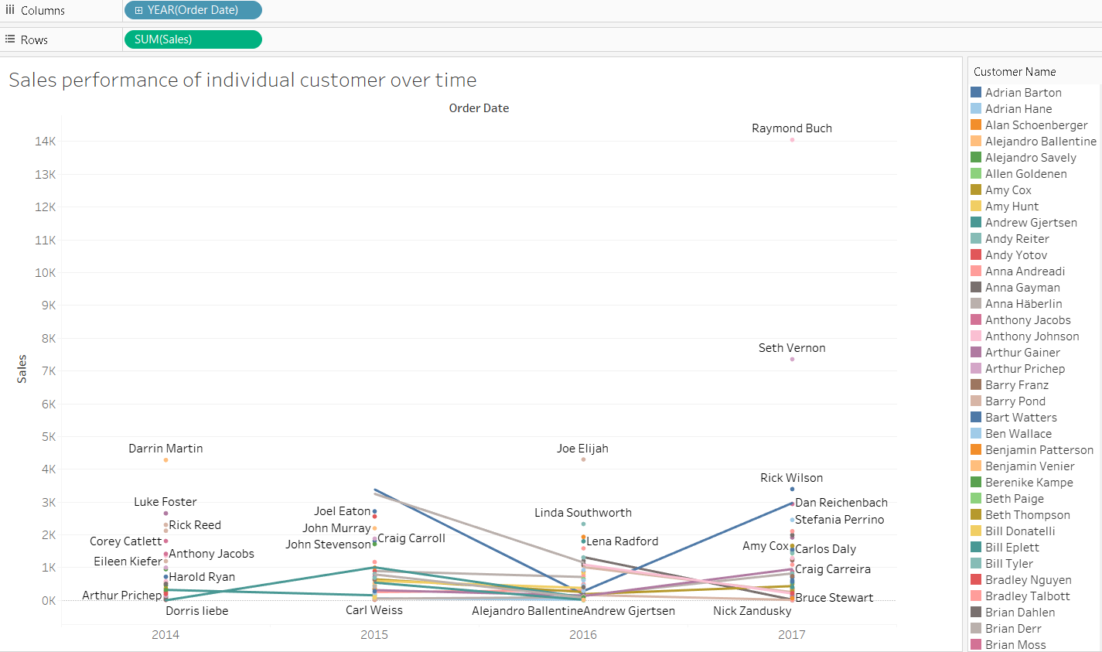

**Justification**: A **line chart** is perfect for showing how a customer's sales trend evolves over time.

1. How do sales vary based on different days of the week and product categories?

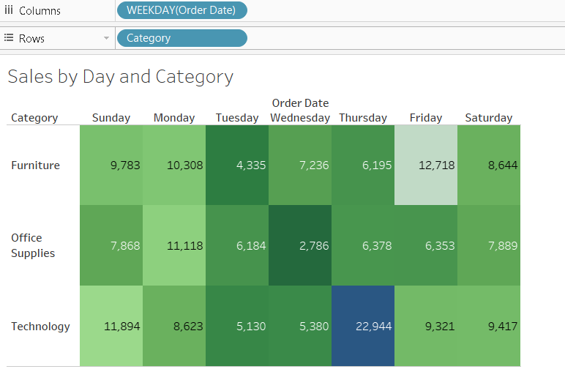

**Justification**: Tracks individual customer sales trends.

1. How is the total sales amount distributed among different product categories?

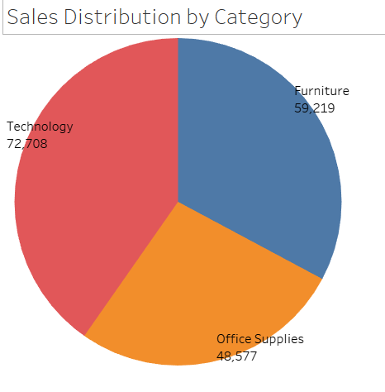

**Justification**: Clearly shows proportion of sales for each category.

1. Can we visualise the sales growth of different product categories over time?

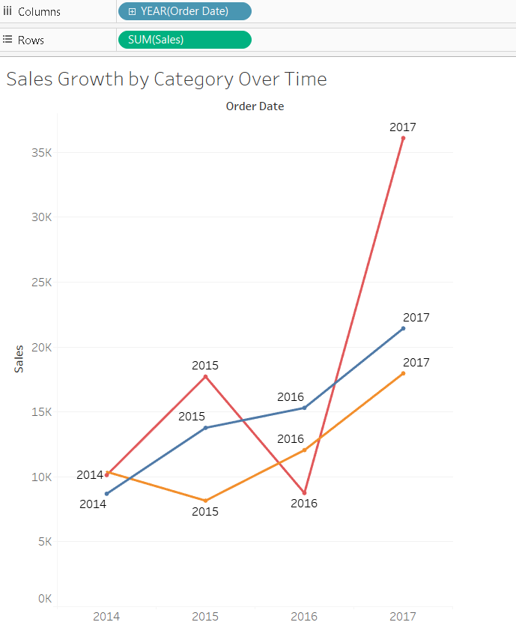

**Justification**: Compares trends across multiple product categories.

1. How does the sales distribution vary across different regions in the "Superstore" dataset?

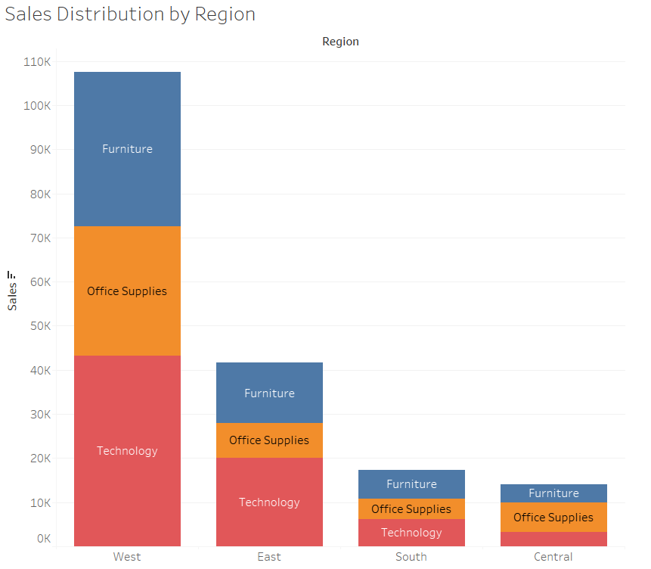

**Justification**: Efficient in visualizing hierarchical segment-subcategory profit data.

1. Can we visualise the composition of profits across various subcategories within different customer segments?

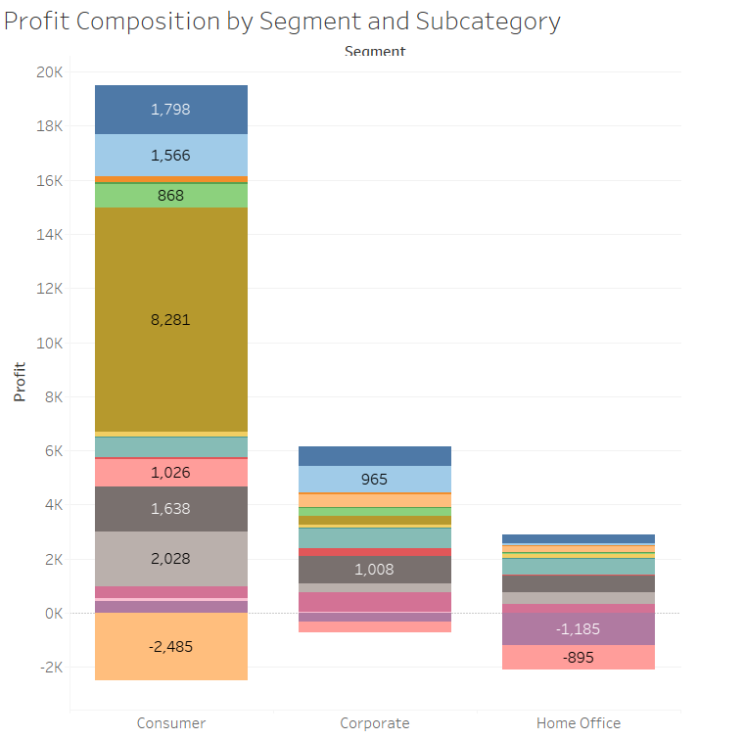

**Justification**: Efficient in visualizing hierarchical segment-subcategory profit data.

1. What is the percentage contribution of each region to the overall sales?

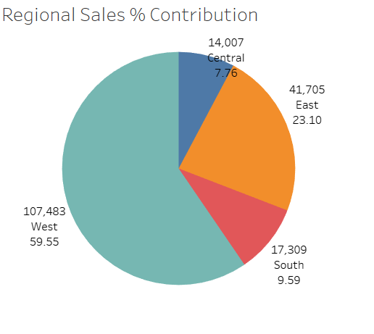

**Justification**: Effective for visualizing percentage distribution.

1. Can we visualise the profit margins associated with different shipping modes and customer segments?

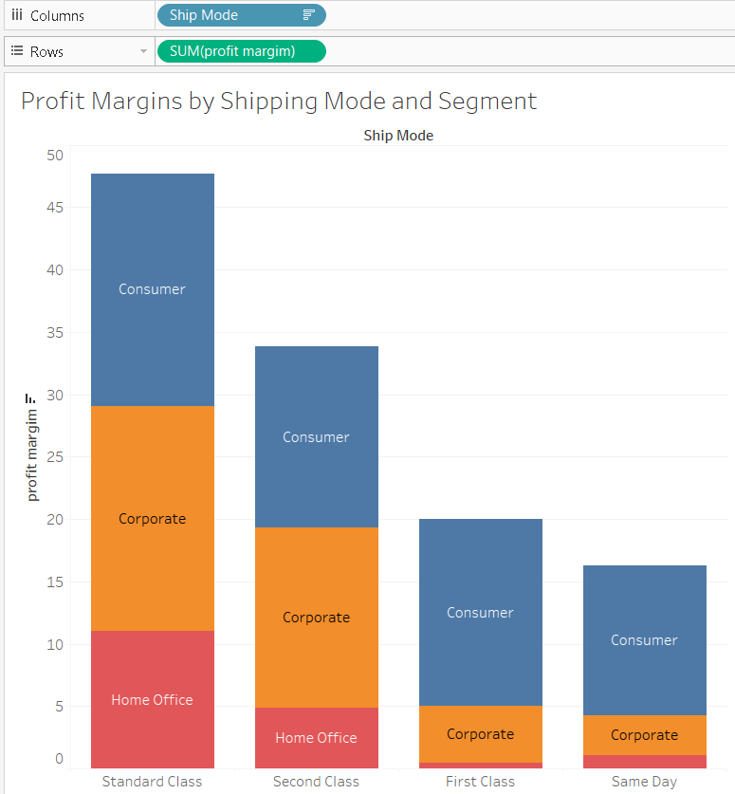

**Justification**: Great for comparing across two categorical variables.

1. How long does it take to process orders for different product categories?

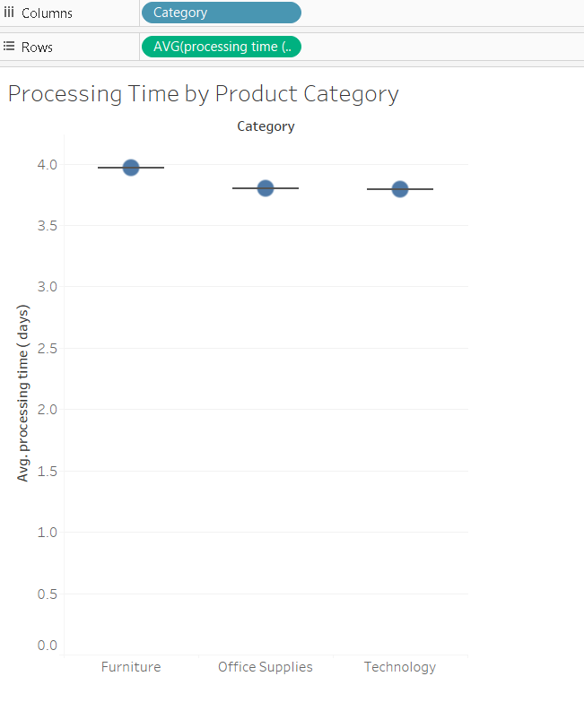

**Justification**: Captures spread and outliers in processing times.

1. How do discounts affect overall profit?

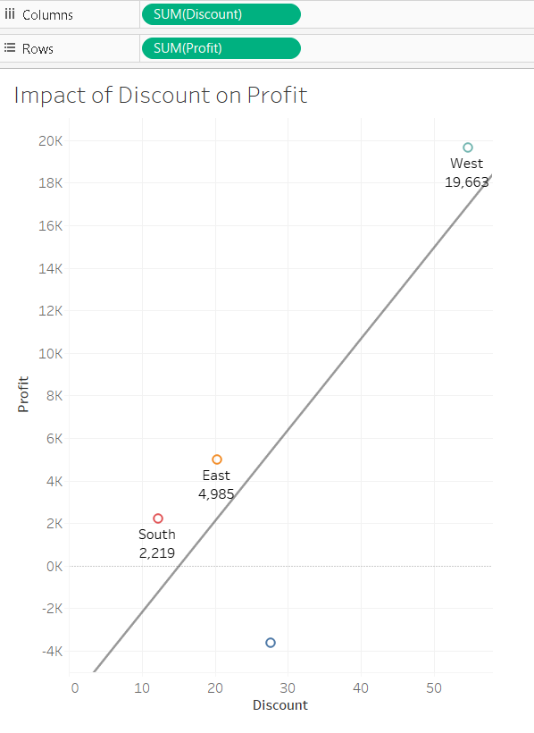

**Justification**: Shows correlation or lack thereof between two numeric variables.

1. Can we visualise the relationship between product sales and profitability for different product categories?

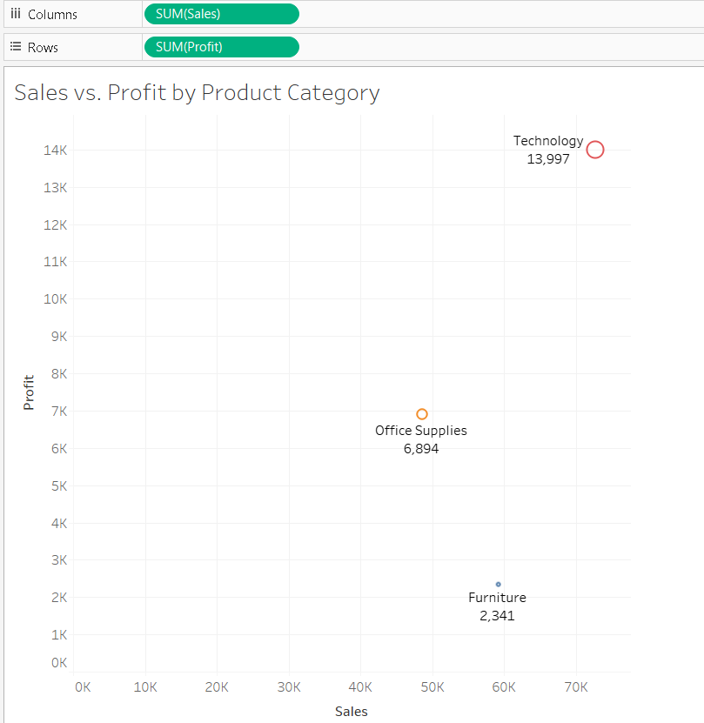

**Justification**: Combines category, sales (size), and profit (color/position).

1. What is the distribution of order quantities for products in the dataset?

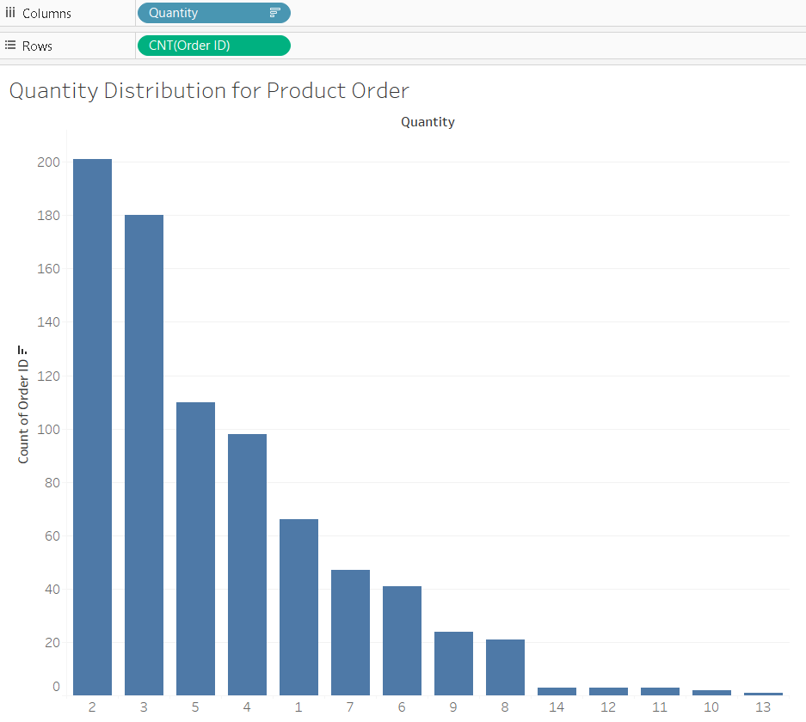

**Justification**: Shows frequency of different order quantity ranges.

1. How do the profit distributions vary across different product categories?

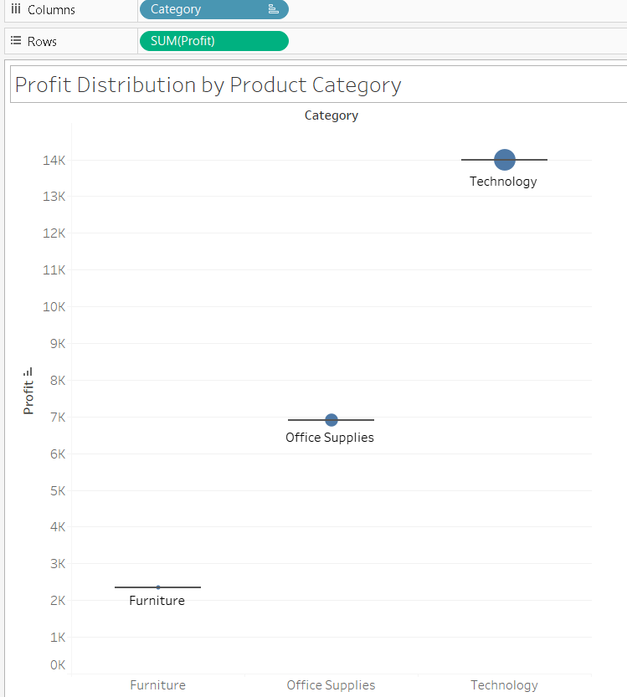

**Justification**: Ideal for showing spread and central tendency.

1. Can we compare the shipping time distributions for different shipping modes?

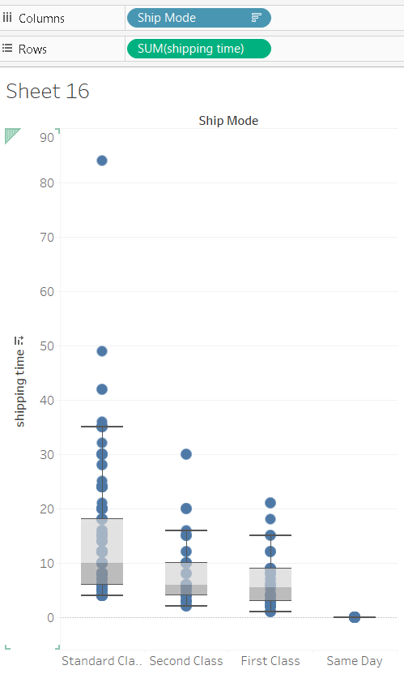

**Justification**: Captures distribution shape and summary statistics.

1. What is the monthly trend in the number of orders shipped?

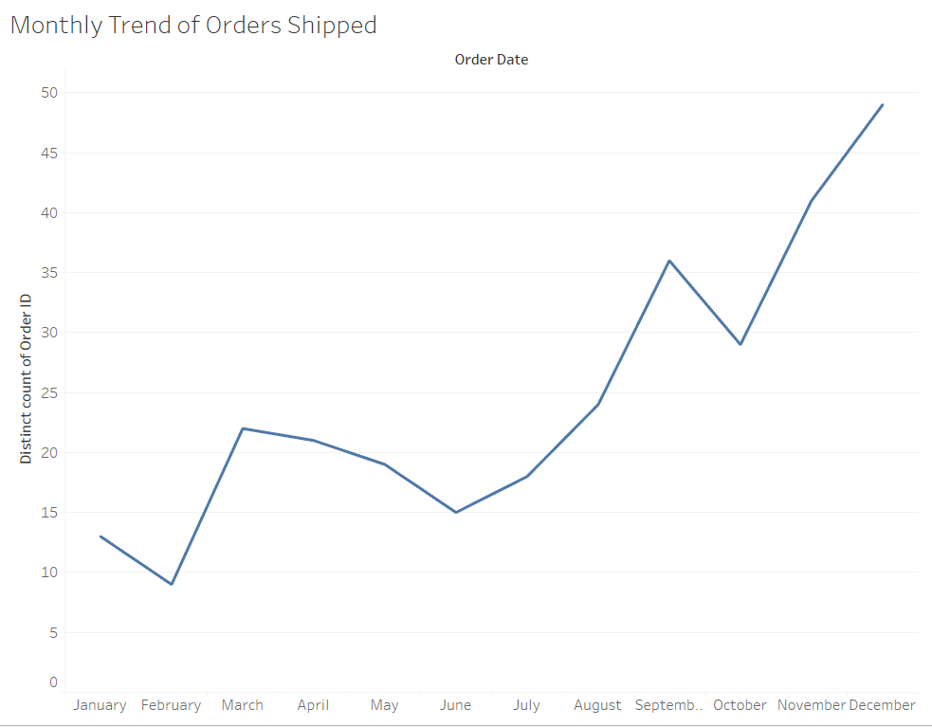

**Justification**: Excellent for visualizing trends and seasonality.

1. How do different customer segments perform in terms of sales and discount rates?

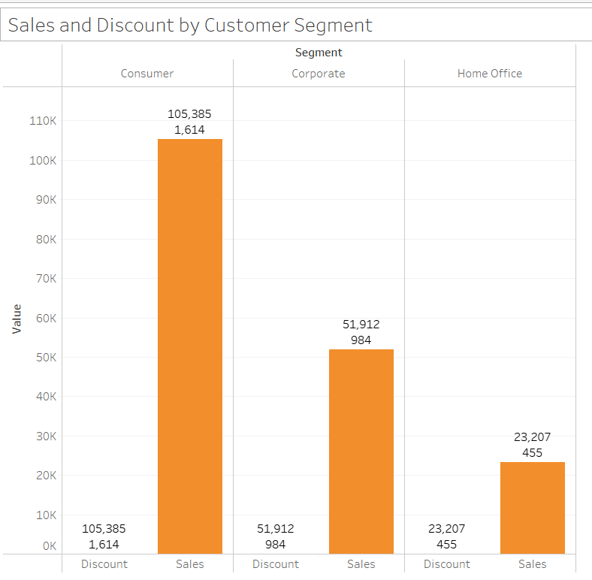

**Justification**: Clear comparative view across customer segments.

1. What are the sales and profit trends across different product subcategories and regions in the Superstore dataset?

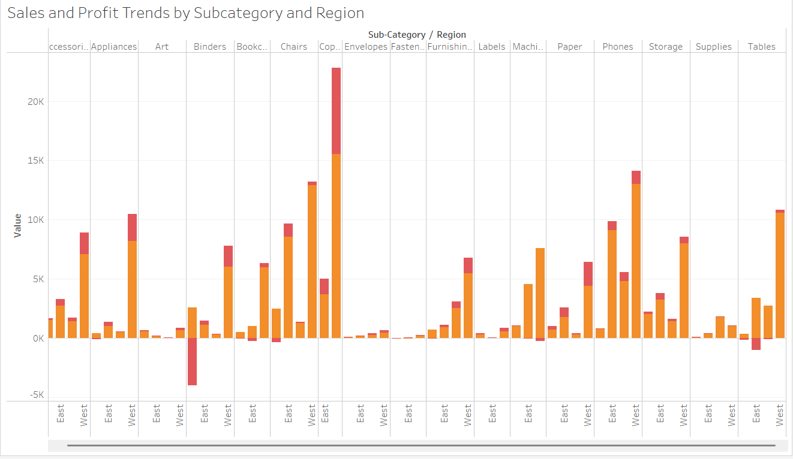

**Justification**: Visualizes two measures across dimensions.

1. What is the average delivery duration for different regions and ship modes?

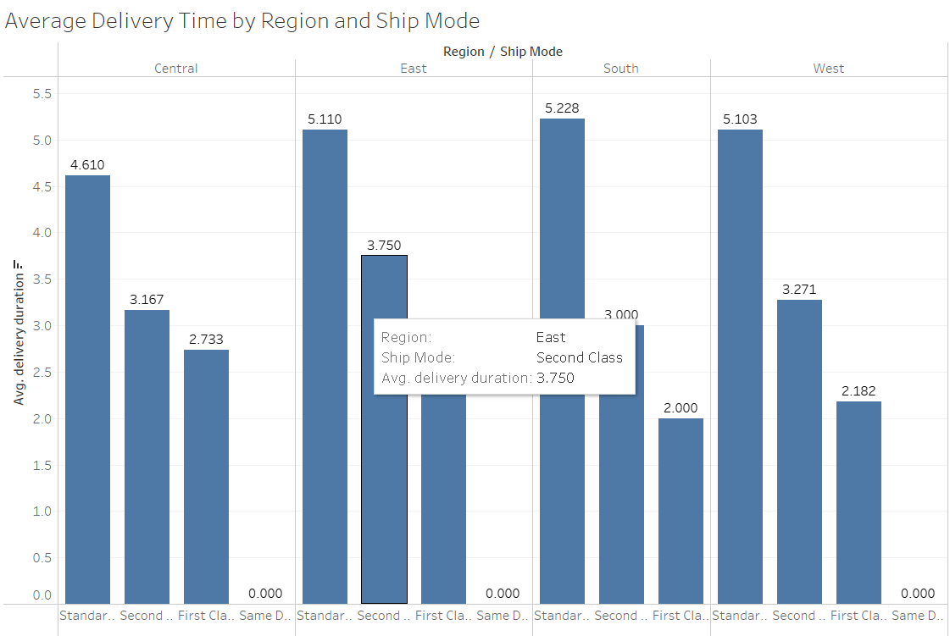

**Justification**: Enables comparison across multiple categorical values.

1. How has the average order quantity changed over the years for various product categories?

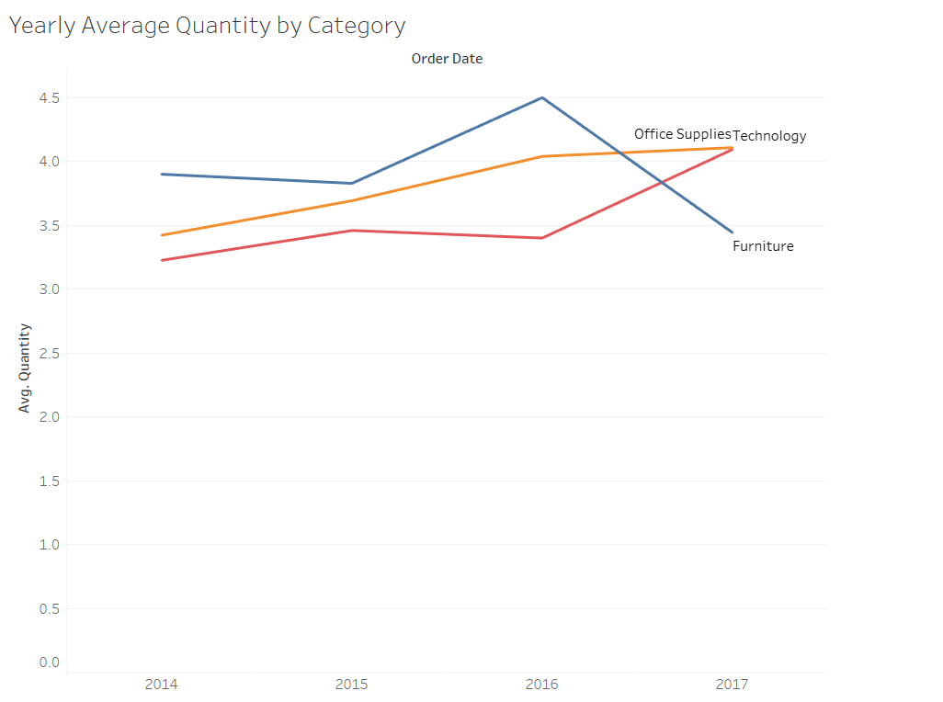

**Justification**: Shows yearly trends per category.

1. Can we visualise the correlation between discount rates and order quantities for different customer segments?

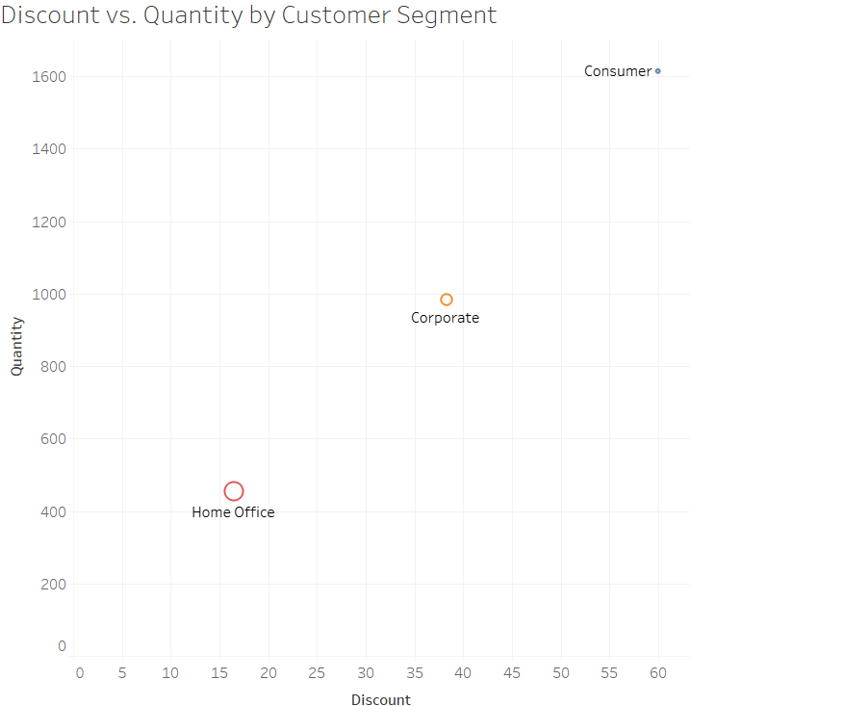

**Justification**: Ideal for visualizing correlation by segment.

1. What is the proportion of orders returned in each region within the Superstore dataset?

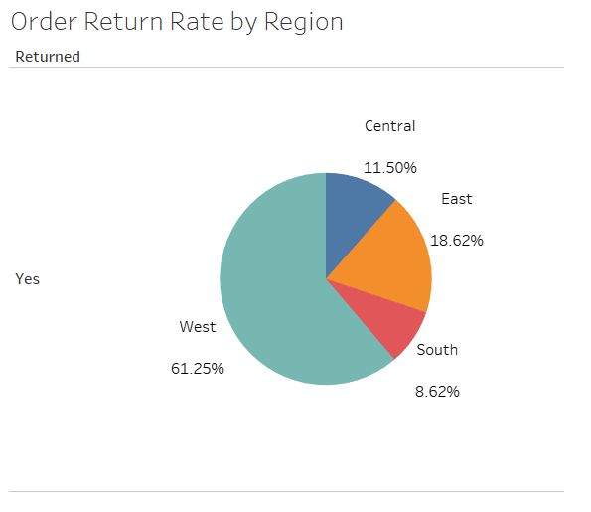

**Justification**: Simple breakdown by region.

1. Can you compare the profit of different products for different subcategories?

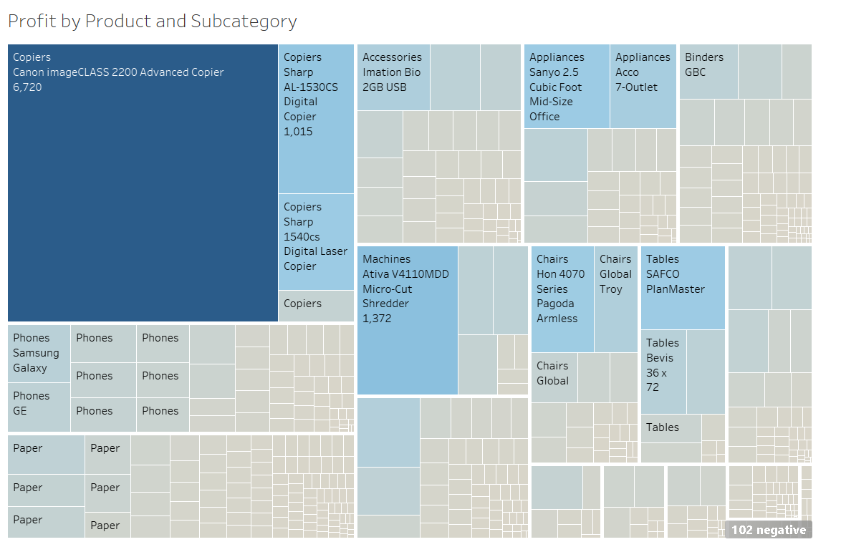

**Justification**: Treemap captures hierarchical data effectively.

1. Which shipping mode is the most commonly used in the Sample Superstore dataset?

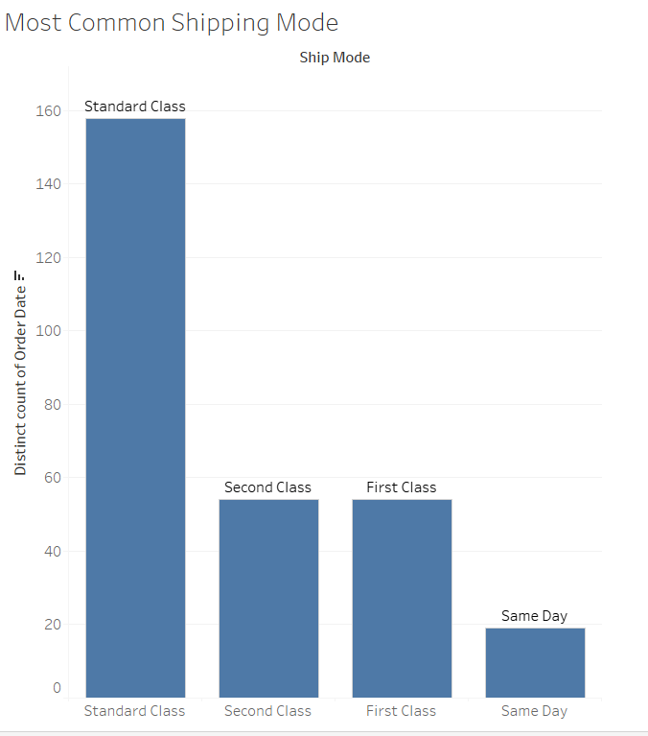

**Justification**: Easily identifies most-used mode by count.

1. How does the sales performance of different regions evolve throughout the quarters of a year?

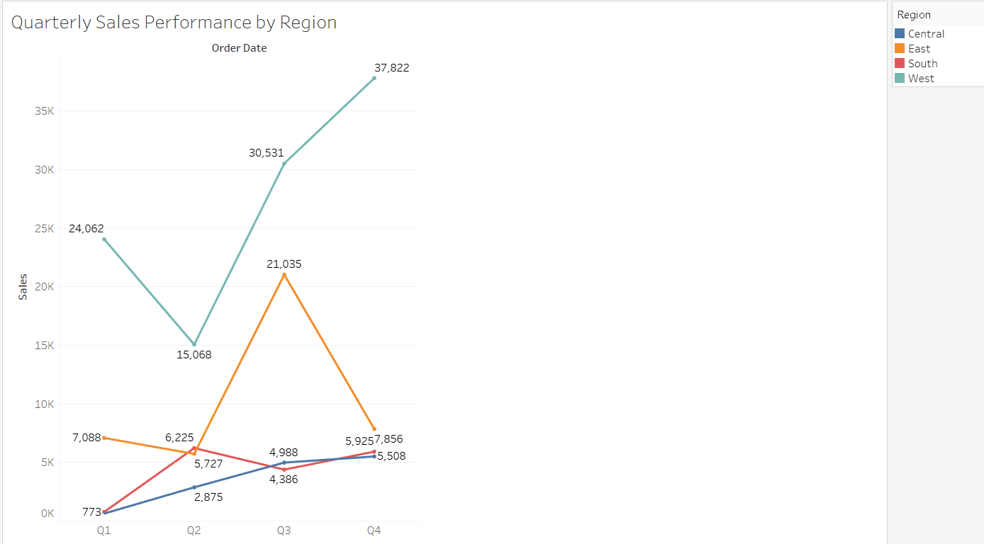

**Justification**: Enables time-based comparisons across regions.

1. What is the relationship between discounts and sales?

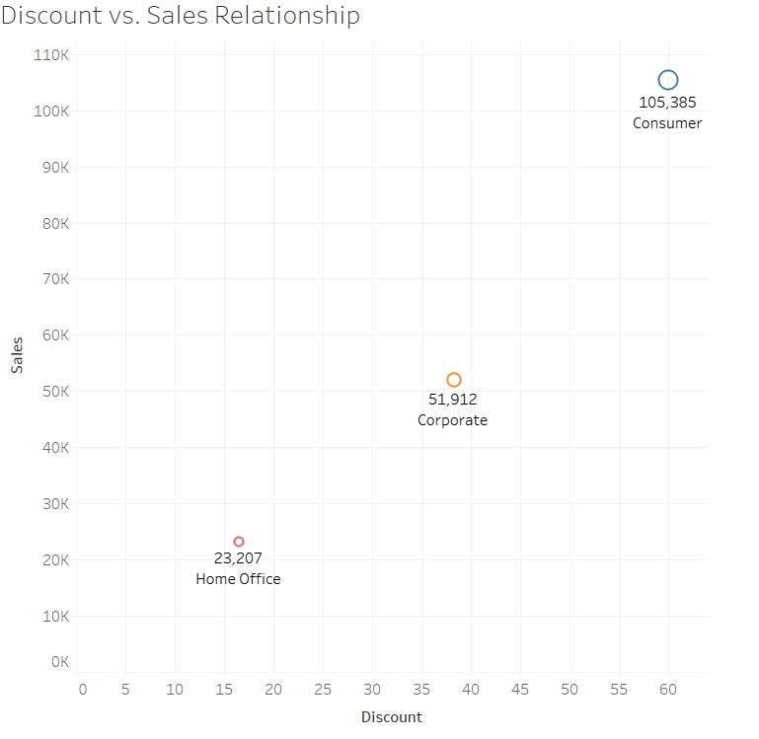

**Justification**: Reveals how sales values respond to discounts.